Lecture 3 Notes:

Note: Convolutional Neural Networks are almost exclusively used with images as inputs!

6: Convolutional Neural Networks are used to simplify / compress very dense information (high density data) in order to make using machine learning methods easier / more efficient.

12: The Auto Encoder can create labels (does not need them to work)🡪 Very useful since labelling is usually very time consuming

17: More simple layers increase accuracy.

20: The reason for using mini batches is usually limited computing power.

28: Regularization: This is a form of regression, that constrains/ regularizes or shrinks the coefficient estimates towards zero. In other words, this technique discourages learning a more complex or flexible model, so as to avoid the risk of overfitting.

A simple relation for linear regression looks like this. Here Y represents the learned relation and β represents the coefficient estimates for different variables or predictors(X).

Y ≈ β0 + β1X1 + β2X2 + …+ βpXp

The fitting procedure involves a loss function, known as residual sum of squares or RSS. The coefficients are chosen, such that they minimize this loss function.

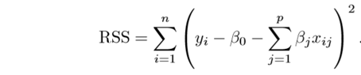

Now, this will adjust the coefficients based on your training data. If there is noise in the training data, then the estimated coefficients won’t generalize well to the future data. This is where regularization comes in and shrinks or regularizes these learned estimates towards zero.

36: F Score helps you actually choose the best algorithm because it balances the above mentioned ideas.